# CA Prototype User Testing Functionality Feedback

Throughout the duration of the user testing session, many of the users gave similar feedback on features that could be added for improvement. The features have been gathered and prioritized below. The first item should have the highest priority, and the last should have the least priority.

1. **Shopping cart items should update the price and # of item(s) in your cart header based on authorized user interaction.**
   1. When an authorized user changes the quantity of the item, removes the item, or clicks “update cart” the subtotal cost and header should be updated. Highlighted areas are where the information should update
   2. 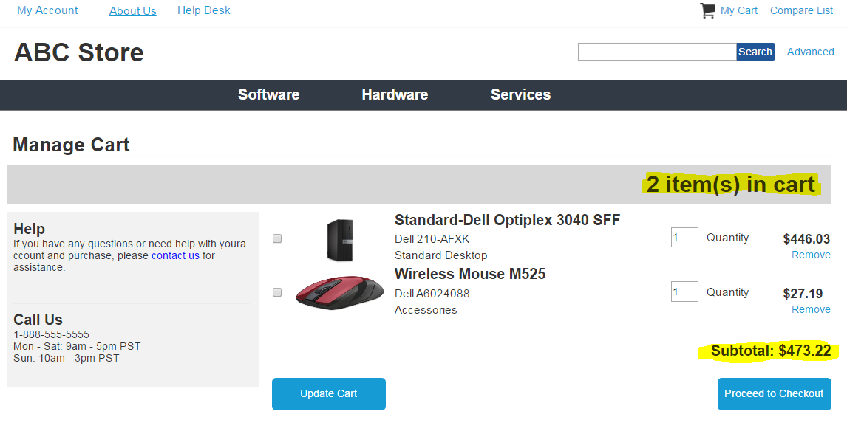
2. **Shipping calculator, cost and options should be present on the Manage Cart screen.**
   1. The authorized user should be able to enter their zip code and choose a shipping method. They should also be able to see the shipping price reflected on the screen based on their choice. The shipping selection and cost should also be stated on the Checkout Information page.
   2. 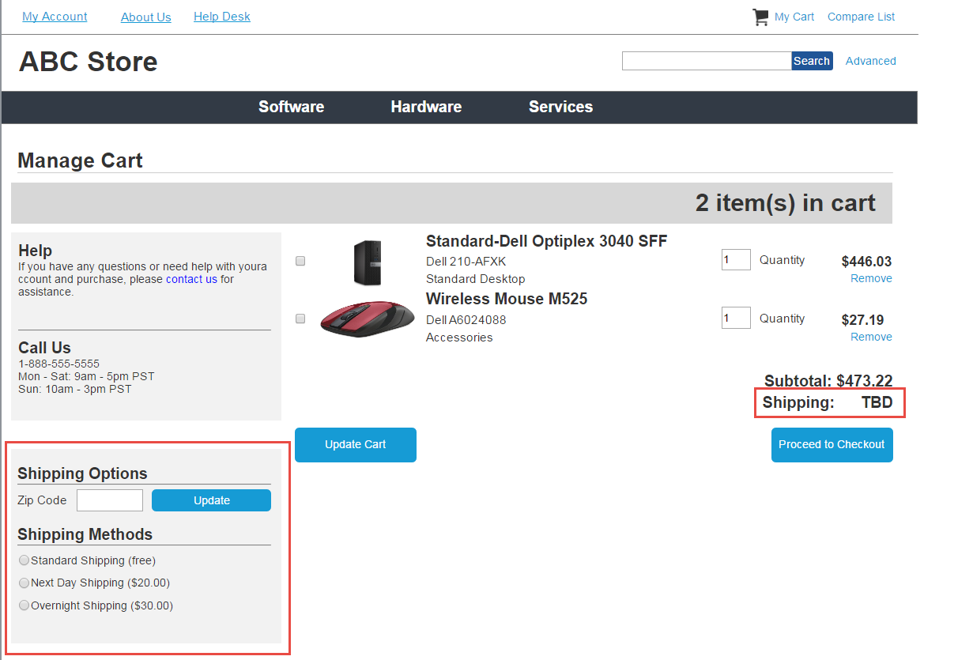
3. **Confirmation page should at least acknowledge that an email confirmation will be sent shortly.**
   1. Although we have decided not to add confirmation emails as a functionality of this prototype, every tester expected the confirmation screen to say an email confirmation will be sent.
   2. **Note from Jenny –** Would it make sense to still add this message on the confirmation page and just mention that the feature itself did not get implemented? It seems to be a core component of the ecommerce shopping experience and questions are automatically asked if there is no mention of email confirmations.
4. **Checkout information fields should have required asterisks**
   1. Each form item should indicate whether or not they are required fields. Fields are highlighted in screenshot below.
   2. 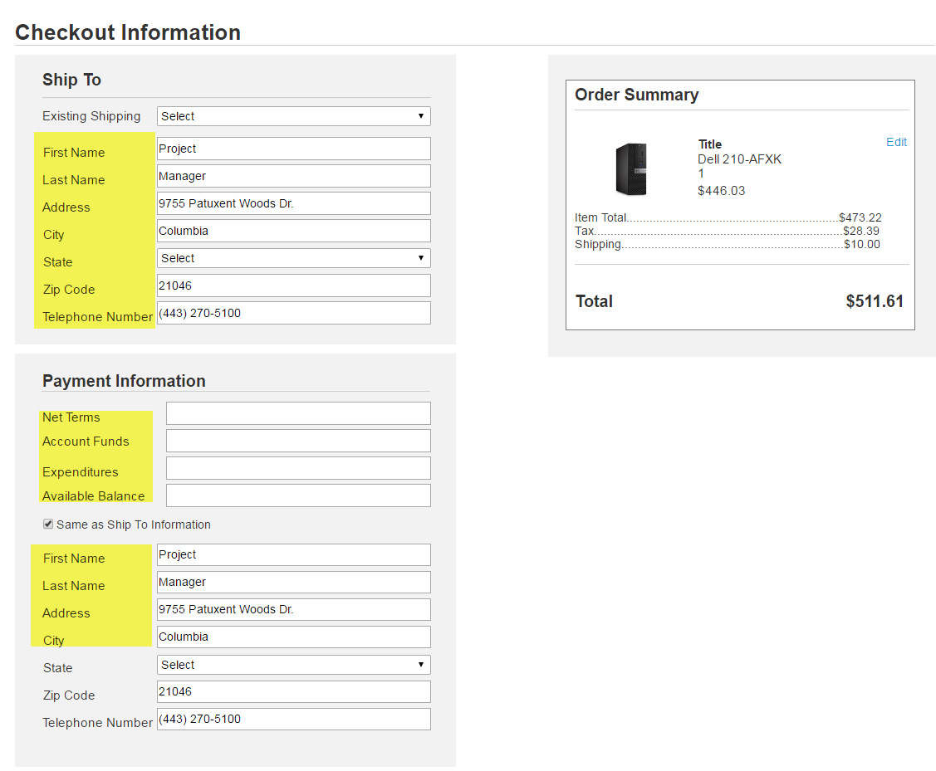
5. **Pricing on Item Detail page should be more visible**
   1. The pricing on the item detail page is not very visible right now. This needs to be made clearer. UI issue to fix.
   2. 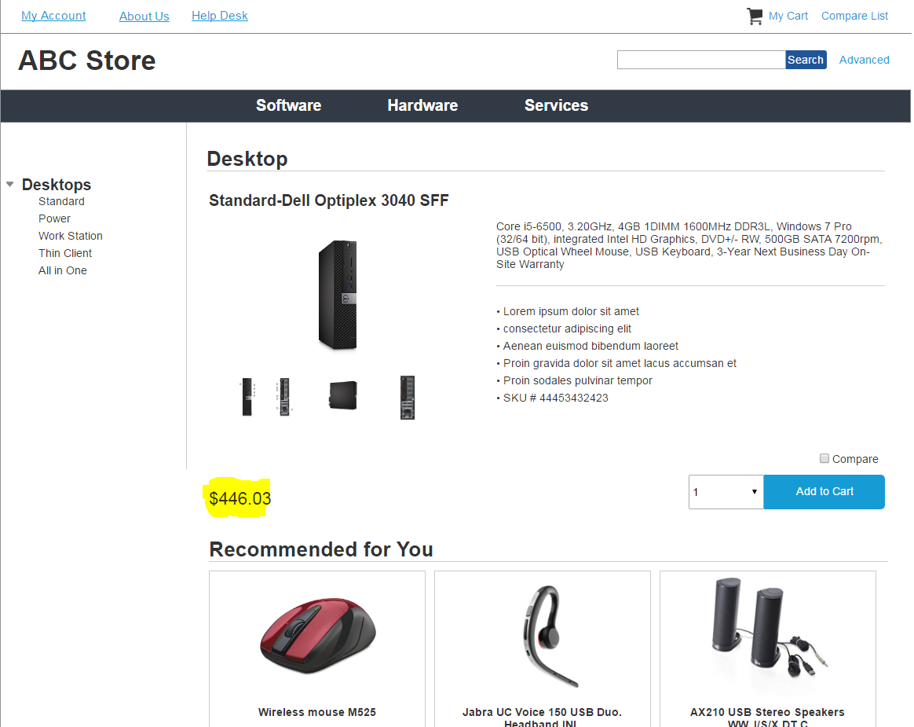
6. **Add “Continue Shopping” button on Order Confirmation page.**
   1. When an authorized user has successfully made a purchase, give them the option to continue shopping with a button that links back to the homepage.
   2. 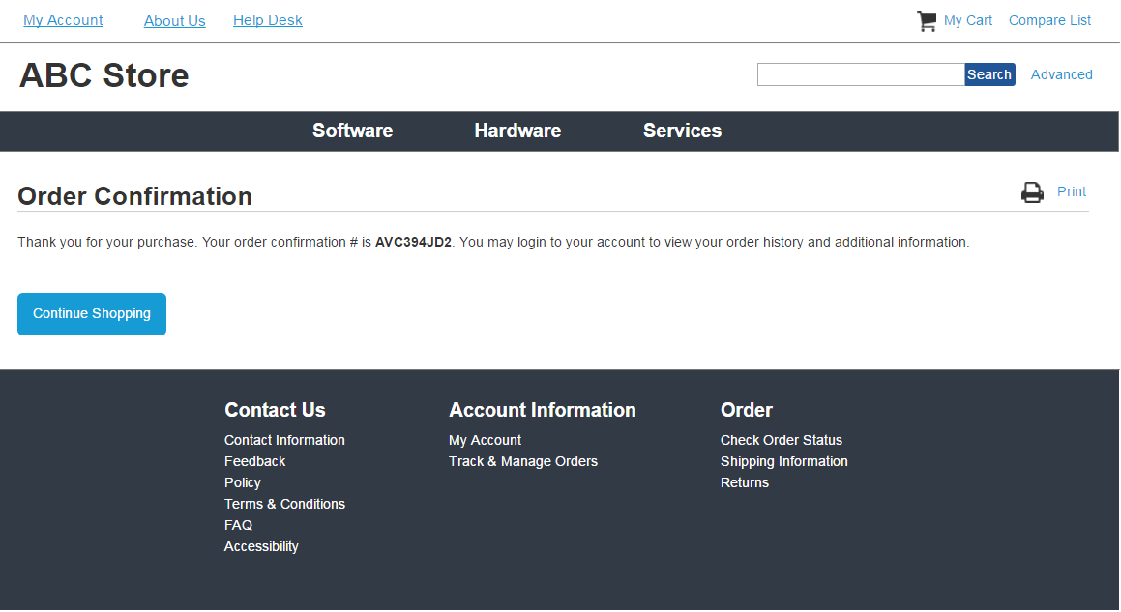
7. **Homepage should have a short paragraph explaining the store**
   1. Instead of just showing “recently purchased items” and “featured products”, also have a brief paragraph at the top of the homepage explaining the store.
   2. **Note from** **Jenny** – I am not sure if this one is necessary or not, since most e-commerce websites do not do this. But since this is a government purchasing website, perhaps it would be helpful?
8. **“Advanced” link for advanced search is not prominent enough.**
   1. One tester had difficulty finding the advanced search link. Consider making it more prominent. This is a UI issue.
   2. 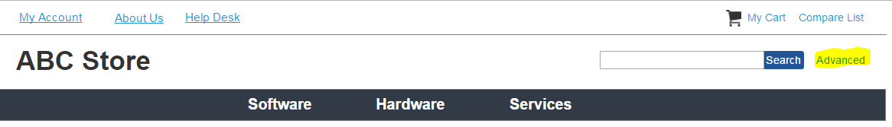

# Other Feedback Comments

1. Overall, the user testing went well. Most users were able to navigate through the order process with little trouble.
2. Once the order process was complete, most users clicked on “Track & Manage Orders” in the footer to navigate to their account as opposed to the “My Account” link in the top header. However, since we are not tracking, the link will have to be revised to “Manage Orders”
   1. 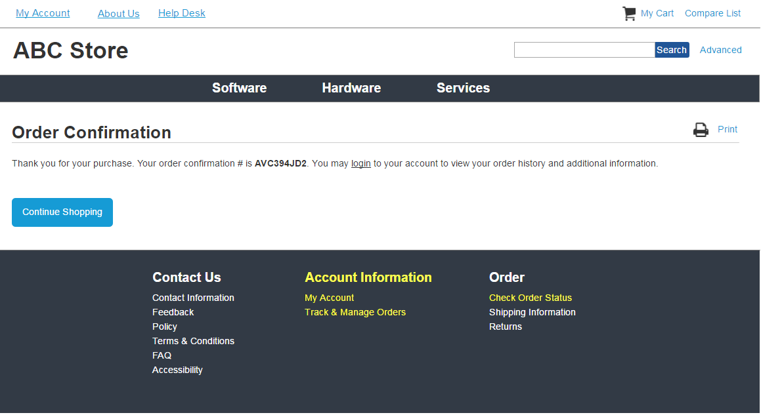
3. This footer will need to be revised because the original concept had a lot more functionality. So I suspect the “Order” column will be removed, as well as many of the “Contact Us” pages.
4. All testers were expecting a tracking code after they completed their purchase.
5. Some testers expected more computer specifications in the comparison list.